Assignment 2
ON

Modeling and Simulation of Hard Drug Consumption and Criminal Behavior using Cell-DEVS

Methodologies for Discrete Event Modelling and Simulation
(Course Code: SYSC 5104)
FALL-2017
Submitted by
Ekambir Sidhu
U-Ottawa Student ID: 300036992
Carleton Student ID: 101098396
Manohar Deep Singh Gill
Carleton Student ID: 101055138
Submitted to
Professor Gabriel A. Wainer
Department of Systems and Computer Engineering
Carleton University, CA

TABLE OF CONTENTS

1. Introduction 3
2. Approach (and Convensions) 3
3. Cell DEVS Formal Specification 7
4. Implementations (Test Models) 10
5. Steps followed in Model Simulation 13
6. Outputs of simulated models 13
7. Conclusion 18

PART I
- INTRODUCTION
In Assignment 2, the criminal activities in an area and the hard drug (for example, cocaine and heroin) consumption has been modelled using three-dimensional Cell DEVS based on the fact that the addiction to the criminal activities leads to increased criminal activities in an area [1]. The primary goal is to implement the three-dimensional Drug Crime Cellular Automata model [1]. The model also takes into account the implementation of incapacitation (treatment of druggists in hospitals) which tends to reduce the druggists/criminal activities in an area, thus influencing the scenario in a positive way. The model incorporates the four basic types of actors/characters: Susceptible Persons (SP), Low Risk Persons (LRP), High Risk Persons (HRP), and Incapacitated persons which are modelled as Cell DEVS in third dimension of the coupled model:
- Susceptible person (SP): A person who do not take drugs, but is likely to start taking drugs in future and will become prone to drugs and criminal activities.
- Low Risk Person (LRP): A person who intakes and consume drugs.
- High Risk Person (HRP): A person who gets addicted to drugs and commits crime to support drug habit.
- Incapacitated person (IP): A person who has been treated by doctors and has returned to the society after treatment.

In Assignment 2, the various three-dimensional cell DEVS test models for analyzing the drug pattern/influence have been implemented, modelled and tested to study the peer associations, the drug usage patterns and criminality dependency.
- APPROACH (AND CONVENSIONS)
The approach used for the implementation of the models have been discussed below:
- The entire workspace is divided into M x N rows and columns of the cells, respectively where M are the number of rows of cells and N are the number of columns of cells.
Note: In the implementation, we have used M=20 and N=20
- Each cell contains one person and the value in the cell represents the state of person. The below table 2 lists the various states a cell can acquire.
Table 1 – Model Transition States
Cell-Color | State of person (or cell) | Description
 | 0 | Indicates that a person in cell do not consume drugs and is not involved in any criminal acquittances, but can be influenced by the druggists in the neighboring cells and can make transition to type 1 or type 2 and type 3.  Healthy Non-Druggist Person (HNP)
 | 1 | Indicates that a person in the cell starts consuming drugs but have not addicted to it and use drugs occasionally.  Low Risk Person (LRP)
 | 2 | Indicates that a person in the cell transitions from a state where he consumes drugs and gets addicted to them.  High Risk Person (HRP)
 | 3 | Indicates that a person consumes drugs heavily and commits crime to support drug habit.  Drug-Crime Transition (DCT)
 | 4 | Indicates the Incapacitated person who has been treated by drugs in the hospital by doctors and has returned to the society. The incapacitated person can stay drug free or can transition to type 1 or type 2 from where he will finally transition to type 3.  Incapacitated person (IP)

Note: The color palate shown above is for the final crime drug model as an example. The palate for other test models has been defined separately and has been explained in detail in PART III of the report.
- The cells neighborhood comprises of the cells encompassing it and the respective cells in the different layers in the model.
- The person in the cells intaking/consuming drugs follows normal distribution and they also effect the neighboring cells.
- The state of the cell is indicated by the value (0,1,2,3 or 4) in it and the color of the cell as shown in Table 1 above. Different models in the Assignment 2 uses different color palates for different cells which are specified in .pal files of the respective models.
- The various models that have been designed, simulated and tested in Cell DEVS have been tabulated in Table 2 below:
Table 2 – Various Test Models implemented in Assignment 2
Model Name | Description
DruggistBasicModel | The model implements the basic model where the cells represent the healthy persons transitioning from state 0 to state 1 indicating that the person start consuming the drugs. The model also takes into account the effect of presence of druggists in the neighboring cells.  Number of Layers in the model: 1
AddictionModel | The model implements Addiction Model where the healthy persons in the cells (type 0) starts consuming drugs (type 1) and finally the transition to drug addiction state (type 2).  Number of Layers in the model: 2
FinalCrimeDrug | The final model which implements all states i.e. a healthy person transforming to Low Risk Person, High Risk Person and Incapacitation state.

The state of person in a cell is controlled by four state variables in the final model: LRP, HRP, crime drug and incapacitation. These variables represent the beginner who has started taking drugs, drug addicted person, phase of drug addicted person who commits crime and the incapacitation stage where the druggist is treated by doctors in the hospital and return to society as healthy beings. It defines a three- dimensional neighborhood and there are four transition functions for calculating the state of each variable in the cell based on the variables of cells within its neighborhood.
To implement this model in Cell DEVS, the persons in the neighborhood will be considered in two-dimensional plane and the four state variables will be considered by a plane in the third dimension in the form of layers.

The variables of LRP, HRP and incapacitation stages are supplied to the cellular automata to simulate complicated drug patterns and crime rate in an area. To generate random drug behavior in the beginning, the variables in some cells status is changed from 0 to 1 following normal distribution and the number of cells whose value is changed to 1 follows normal probability distribution. The cells who are surrounded by the persons who consume drugs are also susceptible and will likely start to consume drugs.

PART II
Formal Cell DEVS Model Specification

- CELL DEVS FORMAL SPECIFICATION
The atomic cellular automaton model (A) is defined by the following specifications:
A = < X, Y, S, N, type, d, τ, δint, δext, λ, ta
X = Y = S = {0,1,2,3,4};
(0:healthy state; 1: LRP state; 2: HRP state; 3: crimedrug state; 4: incapacitation state)
N = { (0,0,-2), (0,0,-1), (0,0,0), (0,0,1), (0,0,2), (0,0,3)
(-2,0,0), (-1,0,0), (1,0,0), (2,0,0),
(0,-2,0), (0,-1,0), (0,1,0), (0,2,0) };
type = transport;
d = { 100 };
δint , δext , λ, and ta are denied using Cell-DEVS specification.

It is to noted that τ(N) depends on location of the cell within the coupled model cell space. Each plane in the third dimension represents the state of particular variable: LRP, HRP, crimedrug and incapacitation such the τ(N) depends on in which plane the cell is located.

Location | τ(N) | Description
τ₁ (0,0,0) | 1 | (0,0,0)=0 AND (0,-1,0)=1 AND (-1,0,0)=1 AND (0,1,0)=1 AND (1,0,0)=1 }  % if the cell is of type 0 and is surrounded by druggists (type 1)
τ₁ (0,0,0) | 1 | { (0,0,0)=0 AND normal(0.4,0.3) > 0.6 }  % generate LRP randomly following normal distribution
τ₁ (0,0,0) | 1 | { (0,0,0)=1 } % remain in that state and sleep if the cell value is 1
τ₁ (0,0,0) | 0 | TRUE
τ₂ (0,0,1) | 2 | { (0,0,0)=0 AND (0,0,-1)=1 AND (0,-1,-1)=1 AND (-1,0,-1)=1 AND (0,1,-1)=1 AND (1,0,-1)=1 }  % HRP transition if the LRP phase is true and LRP s are present in its surroundings
τ₂ (0,0,1) | 2 | { (0,0,0)=2 }  % remain in that state and sleep if the cell value is 2
τ₂ (0,0,1) | 0 | TRUE
τ₃ (0,0,2) | 3 | { (0,0,0)=0 AND normal(0.4,0.1) > 0.6 }  % random generation of crime in an area following normal distribution
τ₃ (0,0,2) | 3 | { (0,0,0)=0 AND (0,0,-1)=2 AND ((0,-1,-1)=2 OR (-1,0,-1)=2 OR (0,1,-1)=2 OR (1,0,-1)=2) }  % if the cell value is zero and the corresponding cell in the layer1 is HRP and is surrounded by HRP from either side showing that the HRP commits crime when in company of other druggist surrounding it.
τ₃ (0,0,2) | 3 | { (0,0,0)=3 }  % remain in that state and sleep if the cell value is 3
τ₃ (0,0,2) | 0 | TRUE
τ₃ (0,0,3) | 4 | (0,0,0)=0 AND (0,0,1)=3 AND ( (1,0,0)=4 OR (2,0,0)=4 OR  (-1,0,0)=4 OR (-2,0,0)=4 OR  (0,1,0)=4 OR (0,2,0)=4 OR  (0,-1,0)=4 OR (0,-2,0)=4 )  % Incapacitation transition if the crime drug phase is true and someone around is incapacitated
 | 4 | { (0,0,0)=0 AND (0,0,-1)=3 AND (0,0,-2)=2 AND normal(0.4,0.3) > 0.1 }  % Incapacitation of the person who is druggist as well as he commits crime
 | 4 | { (0,0,0)=4 }  % % remain in that state and sleep if the cell value is 4
 | 0 | TRUE

The formal Cell DEVS specification of coupled model has been specified below:

crimedrugCA = < X_{list}, Y_{list}, I, X, Y, η, { t₁,t₂, t₃}, N, C, B, Z, select >
X_{list} = { Φ }
Y_{list} = { Φ }
X = Y = { Φ }
η = 12

I = < P^{x}, P^{y} > with P^{x} = { Φ }; P^{y =} { Φ };

N = { (0,0,-2), (0,0,-1), (0,0,0), (0,0,1), (0,0,2), (0,0,3)
(-2,0,0, (-1,0,0), (1,0,0), (2,0,0),
(0,-2,0), (0,-1,0), (0,1,0), (0,2,0) }

t₁ = 20; t₂ = 20, t₃ = 4;

Note: C is the cell space set as specified above.

The cell borders are wrapped but the cells in different planes on third dimension in the cellular model have different transition functions.

B = { (0,0,0)..(19,19,0) use τ_{1;}
(0,0,1)..(19,19,1) use τ₁
(0,0,2)..(19,19,2) use τ₃
(0,0,3)..(19,19,3) use τ₄ }

Z:
P_{i,j,k}^{Y}₁ → P_{i,j,k+1}^{X}₁ P_{i,j,k-1}^{Y}₁ → P_{i,j,k}^{X}₁
P_{i,j,k}^{Y}₂ → P_{i,j,k-1}^{X}₂ P_{i,j,k+1}^{Y}₂ → P_{i,j,k}^{X}₂
P_{i,j,k}^{Y}₃ → P_{i,j,k-2}^{X}₃ P_{i,j,k+2}^{Y}₃ → P_{i,j,k}^{X}₃
P_{i,j,k}^{Y}₄ → P_{i,j,k}^{X}₄ P_{i,j,k+2}^{Y}₄ → P_{i,j,k}^{X}₄
P_{i,j,k}^{Y}₅ → P_{i,j-1,k}^{X}₅ P_{i,j+1,k}^{Y}₅ → P_{i,j,k}^{X}₅
P_{i,j,k}^{Y}₆ → P_{i,j-2,k}^{X}₆ P_{i,j+1,k}^{Y}₆ → P_{i,j,k}^{X}₆
P_{i,j,k}^{Y}₇ → P_{i,j+1,k}^{X}₇ P_{i,j-1,k}^{Y}₇→ P_{i,j,k}^{X}₇
P_{i,j,k}^{Y}₈ → P_{i,j+2,k}^{X}₈ P_{i,j-2,k}^{Y}₈ → P_{i,j,k}^{X}₈
P_{i,j,k}^{Y}₉ → P_{i-1,j,k}^{X}₉ P_{i+1,j,k}^{Y}₉ → P_{i,j,k}^{X}₉
P_{i,j,k}^{Y}₁₀ → P_{i-2,j,k}^{X}₁₀ P_{i+2,j,k}^{Y}₁₀ → P_{i,j,k}^{X}₁₀
P_{i,j,k}^{Y}₁₁ → P_{i+1,j,k}^{X}₁₁ P_{i-1,j,k}^{Y}₁₁ → P_{i,j,k}^{X}₁₁
P_{i,j,k}^{Y}₁₂ → P_{i+2,j,k}^{X}₁₂ P_{i-2,j,k}^{Y}₁₂ → P_{i,j,k}^{X}₁₂

select = { (0,0,-2), (0,0,-1), (0,0,0), (0,0,1),
(-2,0,0), (-1,0,0), (1,0,0), (2,0,0),
(0,-2,0), (0,-1,0), (0,1,0), (0,2,0) };

Note: The simulation model will consist of only one coupled model specified above and has no inputs or outputs to the system.

M = < X, Y, D, {Mi}, {Ii}, {Zij}, select >
X = Y = { Φ }
D = {crimedrugCA}
M = {crimedrugCA}
I = { Φ }
Z = { Φ }
Select = {crimedrugCA}

PART III
Simulation and Results
- Implementation (Test Models):
The three dimensional three models have been implemented in the Cell DEVS as shown below in Table 3 for the testing and illustration point of view.
Table 3 – Implemented Cell DEVS Models
Test Model Name | Description (test cases)
DruggistBasicModel | The model implements the basic model where the cells represent the healthy persons transitioning from state 0 to state 1 indicating that the person start consuming the drugs. The model also takes into account the effect of presence of druggists in the neighboring cells.  This simple model simulates the spread of drugs in an area using cell DEVS approach.  Specifications: Default delay in the model = 200 milliseconds Number of Layers: 1
AddictionModel | The model implements the Addiction Model where the healthy persons in the cells (type 0) starts consuming drugs (type 1) and finally the transition to drug addiction state (type 2). It can also be assumed that the while sharing the needles, it may lead to transfer of infectious diseases from the druggist to person who has started consuming drugs.  Specifications: Default delay in the model = 150 milliseconds Number of Layers: 2
FinalCrimeDrug | The final model which implements the all states i.e. a healthy person transforming to Low Risk Person, then to High Risk Person, committing crime and Incapacitation state.  Specifications: Default delay in the model = 100 milliseconds Number of Layers: 4

The final model has been successfully implemented in CD++ by defining four zones, one for each state variables and providing the separate transition functions for each zone as defined in Part II:
[top]
components : crimedrugCA

[crimedrugCA]
type : cell
dim : (20,20,4)
delay : transport
defaultDelayTime : 100
border : wrapped

neighbors : crimedrugCA(0,0,-3) crimedrugCA(0,0,-2) crimedrugCA(0,0,-1) crimedrugCA(0,0,0) crimedrugCA(0,0,1) crimedrugCA(0,0,2) crimedrugCA(0,0,3)
neighbors : crimedrugCA(0,-1,-1) crimedrugCA(0,1,-1) crimedrugCA(-1,0,-1) crimedrugCA(1,0,-1)
neighbors : crimedrugCA(-2,0,0) crimedrugCA(-1,0,0) crimedrugCA(1,0,0) crimedrugCA(2,0,0)
neighbors : crimedrugCA(0,-2,0) crimedrugCA(0,-1,0) crimedrugCA(0,1,0) crimedrugCA(0,2,0)

zone : LRP-transition { (0,0,0)..(19,19,0) }
zone : HRP-transition { (0,0,1)..(19,19,1) }
zone : crimedrug-transition { (0,0,2)..(19,19,2) }
zone : Incapacitation-transition { (0,0,3)..(19,19,3) }

localtransition : default-rule

initialvalue : 0

[LRP-transition]
rule : 1 100 { (0,0,0)=0 AND (0,-1,0)=1 AND (-1,0,0)=1 AND (0,1,0)=1 AND (1,0,0)=1 }
rule : 1 100 { (0,0,0)=0 AND normal(0.4,0.3) > 0.6 }
rule : 1 100 { (0,0,0)=1 }
rule : 0 100 { t }

[HRP-transition]
rule : 2 100 { (0,0,0)=0 AND (0,0,-1)=1 AND (0,-1,-1)=1 AND (-1,0,-1)=1 AND (0,1,-1)=1 AND (1,0,-1)=1 }
rule : 2 100 { (0,0,0)=2 }
rule : 0 100 { t }

[crimedrug-transition]
rule : 3 100 { (0,0,0)=0 AND normal(0.4,0.1) > 0.6 }
rule : 3 100 { (0,0,0)=0 AND (0,0,-1)=2 AND ((0,-1,-1)=2 OR (-1,0,-1)=2 OR (0,1,-1)=2 OR (1,0,-1)=2) }
rule : 3 100 { (0,0,0)=3 }
rule : 0 100 { t }

[Incapacitation-transition]
rule : 4 100 { (0,0,0)=0 AND (0,0,-1)=3 AND (0,0,-2)=2 AND normal(0.4,0.3) > 0.1 }
rule : 4 100 { (0,0,0)=4 }
rule : 0 100 { t }

[default-rule]
rule : {(0,0)} 100 {t}

The 20x20 cell space has been created and the cells are initialized with zero value. The normal() function has been used to generate state 1 variables in order to evolve the simulation.

- Steps followed in the model simulations:
- Select the perspective to Cell DEVS by selecting window -> Open Perspective -> Others -> select Cell DEVS.
- The .ma file of the respective model have been used to generate the .log file using ‘Simulate Project’
- Create the .drw files for the respective models by using the .ma and .log files in ‘Drawlog your models’ dialog.
- Create the val file by using the ‘Create val file with random initial state’ by using the .ma file for the respective model. Choose the option ‘Fill the n number of cells with {1}. Fill the rest of cells with {0}’. Choose the value of n as 0 (zero).
- Generate color palette and save the file with .pal.
- Run and simulate the project in CD+ Modeller using the respective .drw and .pal files of the respective models.
- The project can also be run by using the CD++ Web Viewer (http://omarhesham.com/arslab/webviewer/). The .ma, .drw, .val and .pal files are required to simulate a model in CD++ Web Viewer.
- The simulated results of the models can be recorded by using the ‘record video’ function in CD++ Web Viewer or by using camstudio. The output video has been recorded in avi format.

- Output(s) of the Simulated Models
- Druggist basic model
The output of druggist basic model showing the simulation has been recorded in druggistbasicmodel.avi file in the form of video and the snapshot at 0 seconds, seconds and 5 seconds is shown below in Figure 1 where the yellow color the healthy persons (Susceptible person) and the green cells shows the Low Risk Person who has started taking drugs.
Low Risk Person (LRP)
Susceptible Person (SP) <= COLOR PALATE FOR THE MODEL
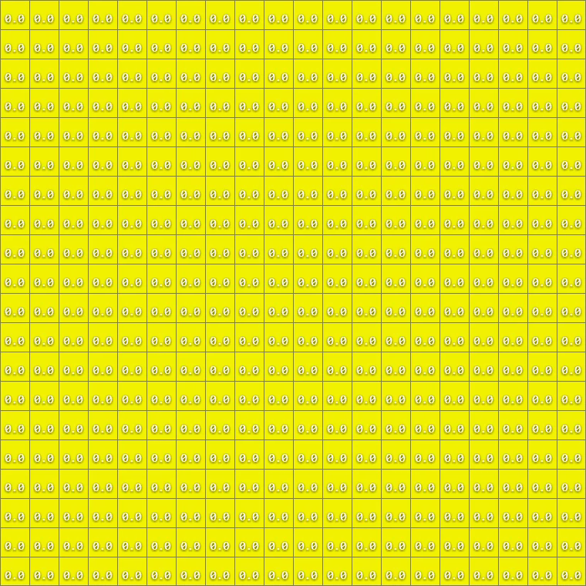
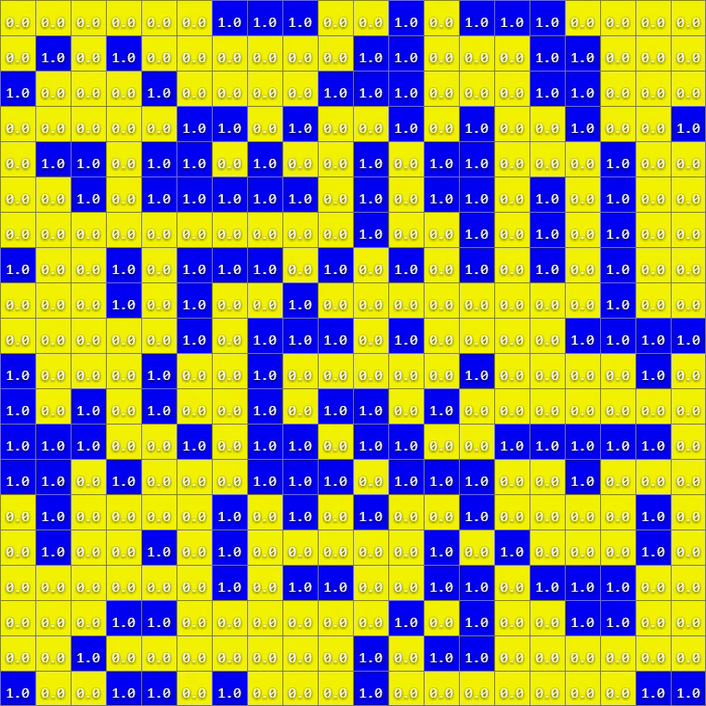
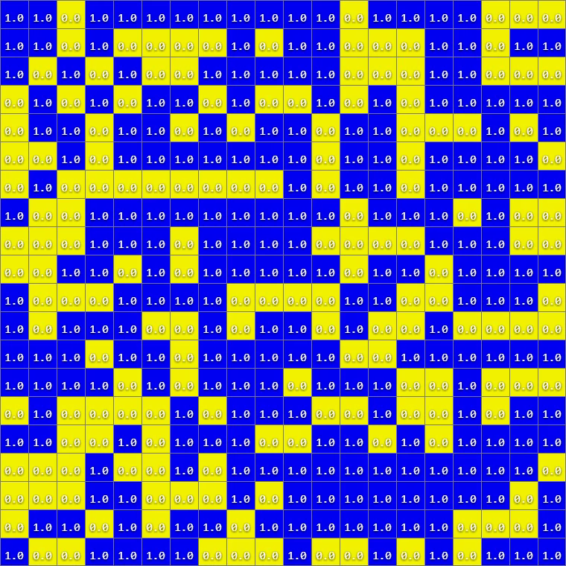
Healthy Person (in yellow)
Druggist (in blue)
Figure 1 – Druggist Basic Model simulation output at t1=0 seconds, t2=12 seconds and t3=5 seconds showing the random generation of druggists in an area in blue color following random normal distribution and effect the people in neighboring community
The model is consistent due to the normal probability distribution used to generate the druggists in an area.
- Addiction Model
The addiction model shows the basic three-dimensional implementation in Cell DEVS where a susceptible person (SP) transforms into Low Risk Person (LRP) and finally transforms into high risk person (HRP) following normal distribution. The color palate for this model is shown below:
White indicates the Susceptible Person (SP i.e. non-druggist healthy person)

Green indicates the Low Risk Person (LRP)<= COLOR PALATE FOR THE MODEL

Red indicates the High-Risk Person (HRP i.e. drug addicted person)

The below figure 2 shows the transitions in the model from susceptible person (SP) transforms into Low Risk Person (LRP) and finally transforming into high risk person (HRP) at t=5 seconds. It is to be noted that the transition from LRP to HRP depends on the presence of addicted persons (type 2) in the surroundings and also follows random normal distribution.

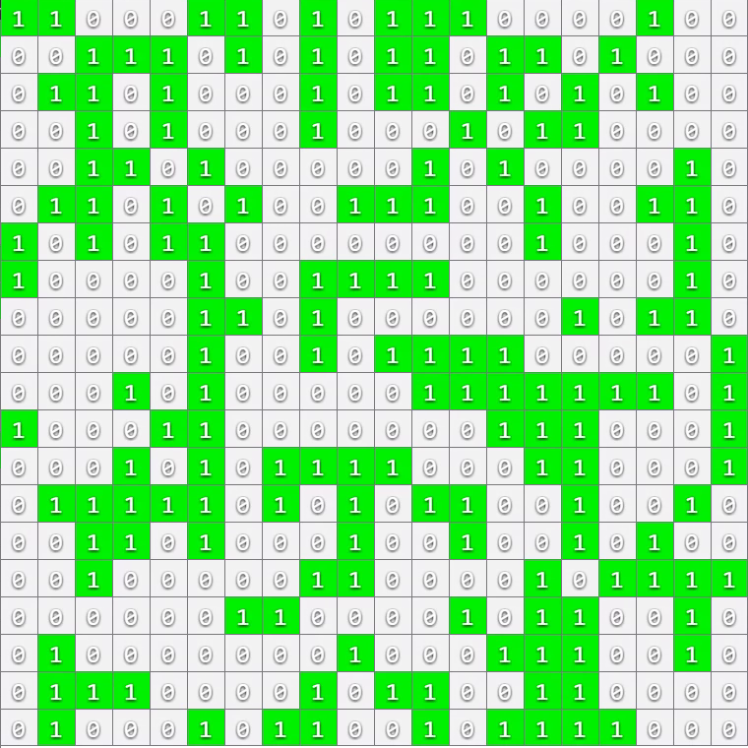
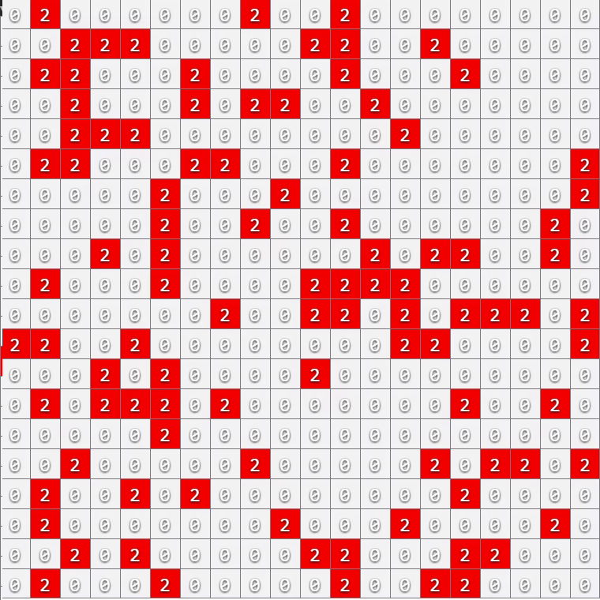
Healthy Person (in white)
LRP (in green)
HRP (in red)

Figure 2 – Addiction Model simulation output at t=5 seconds showing the healthy but susceptible persons (in white) transforming into LRP (in green) and LRP to HRP (in red – addicted persons) following normal distribution
(C) Final Crime Drug CA Model
The following figure 3 shows the Susceptible – LRP - HRP - Crime -Incapacitation transition at 5 seconds and 10 seconds time instant is shown in Figure 3 below. It is to be noted that the transitions from Susceptible to LRP and then from LRP to HRP transition follows random normal probability distribution along with the consideration of neighboring cells.
The color palate used for the model simulation has been described below:
Indicates susceptible person

Indicates LRP Person

Indicates HRP Person

Indicates Crime commit

Indicates Incapacitation

The below figure 3 shows the final model simulated output at t = 5 seconds.
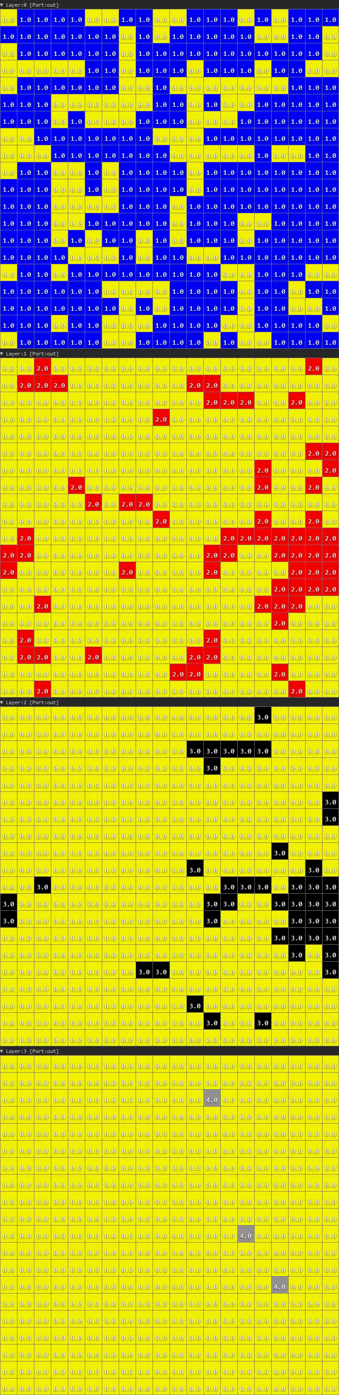
Person starting intake of drugs (LRP)

Susceptible persons in yellow transforming into Low Risk Persons (1) at t=5seconds

Person addicted to drugs (HRP)

Low Risk Persons transforming into High Risk Persons (2) at t=5 seconds

Drug Addicted Person committing crime

Incapacitation transition stage (4) at t=5 seconds
Crime not involving any druggist person (non-druggist crime nature)

Incapacitation of Addicted Criminal Person

Transition from High Risk State to Crime state (3) at t=5 seconds
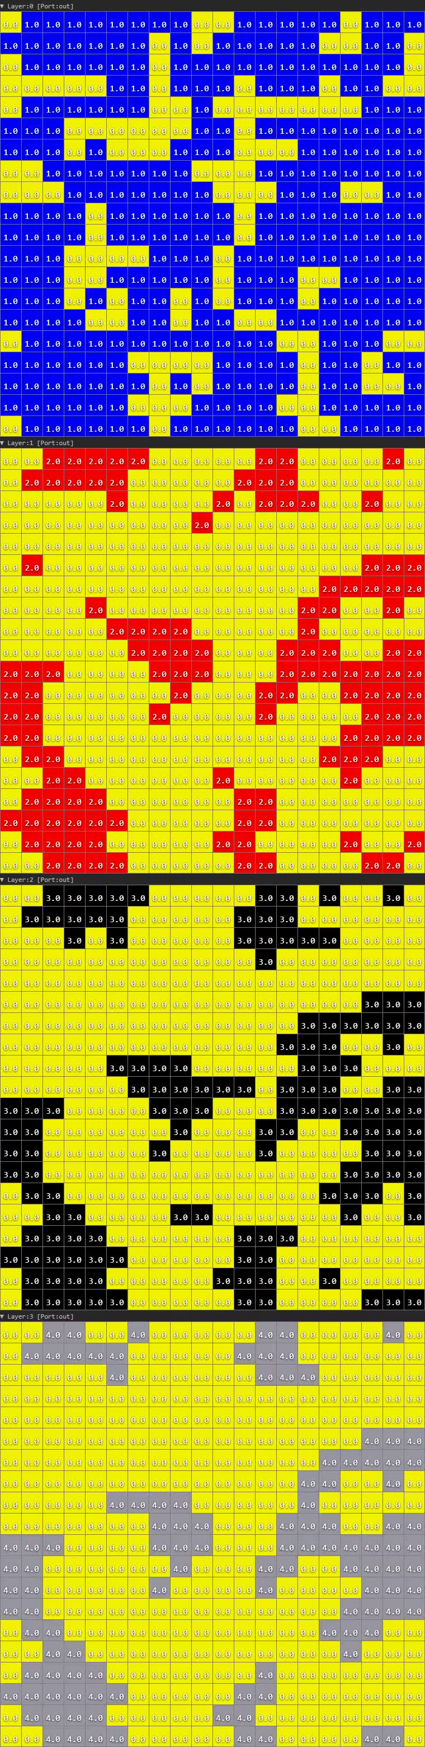
Person starting intake of drugs (LRP)

Susceptible persons in yellow transforming into Low Risk Persons (1) at t=10 seconds

Person addicted to drugs (HRP)

Low Risk Persons transforming into High Risk Persons (2) at t=10 seconds

Person addicted to drugs committing crime

Incapacitation transition stage (4) at t=10 seconds

Incapacitation of addicted criminal Person

Transition from High Risk State to Crime state (3) at t=10 seconds

Conclusion:
The crime drug model has been successfully implemented in the Cell DEVS and the various intermediate models illustrating the working and simulation process through various test cases for modeling the crime drug scenario in an area have been implemented. The implemented model is an approximate model due to the probabilistic nature (i.e. the random normal distribution is used to create the druggists in model simulation and for the transition to crime) implemented through visual simulation.
The implemented model is a three-dimensional CELL DEVS model where the third dimension represents the transition states in the model implementation. It has been observed that all the models are working correctly and the respective .ma, .pal, .val, .drw and .log files for the corresponding models have been generated.

